Crypto Failures Solution Documentation
Written By: Yuval Quina
I started this challenge by executing a Nmap ports and services scan:
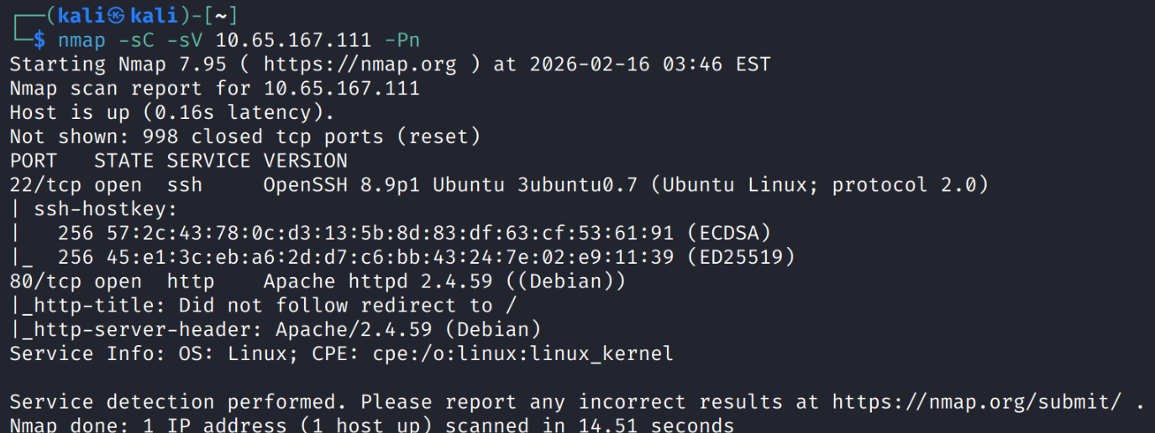
It seems the target has 2 open ports: 80 (http), 22(ssh). Therefore, I access the target via its website:
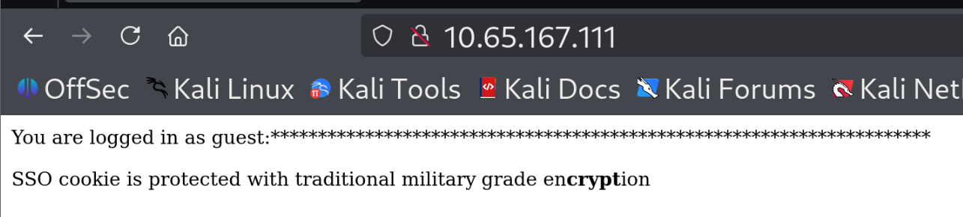
The website showed me that I logged in as a guess and that there is a SSO (Single Sign On – a technology that enable users to login once and to be recognized across multiple platforms that trust each other’s identification system. A good example to this is the option of many web apps to recognize you after “connecting with google account”).
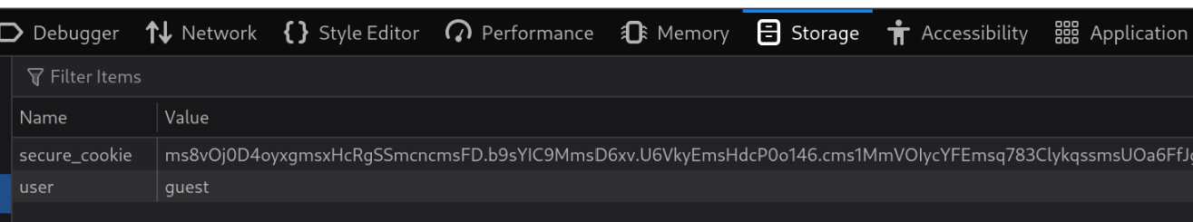
I opened my browser storage and found there 2 cookies:
- secure_cookie – probably the SSO cookie
- user – the user cookie
At this point, I thought to myself what will happen if I will change the user cookie value from “guest” to “admin”:
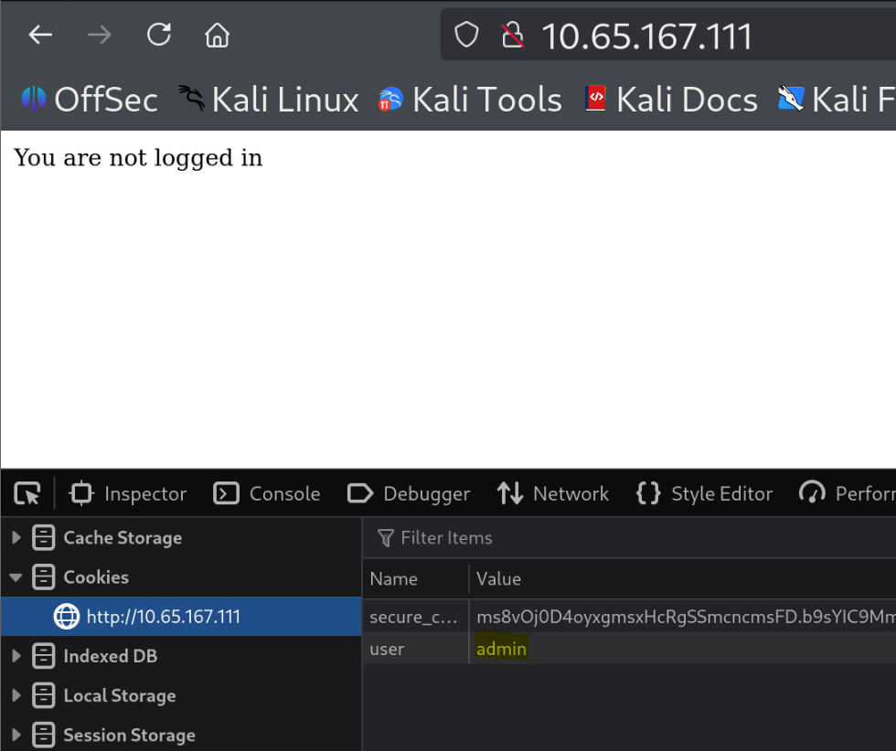
And the website reply that I don’t login as admin, apparently because of the SSO cookie.
I chose to open to inspector to try and find hidden data:
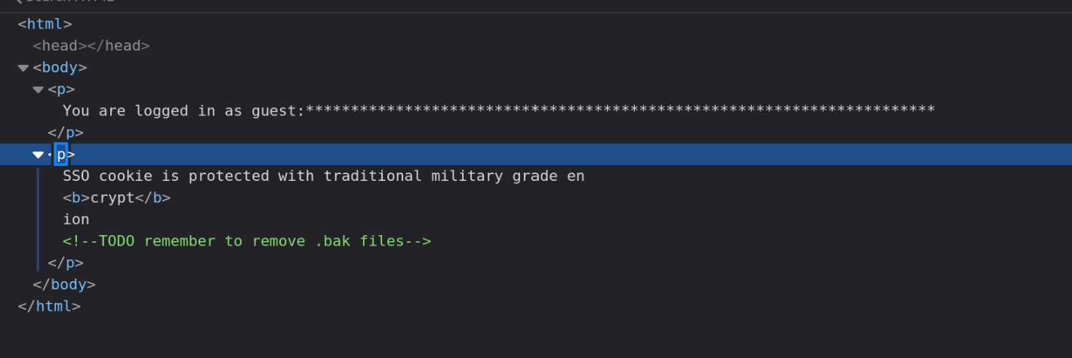
I noticed a comment from the website developer about a TODO task that he wrote to himself which is to remove .bak files. I took it into consideration, and I started to look for .bak files (a common file extension used for backup copies of files and databases) by fuzzing possible files names using Gobuster:
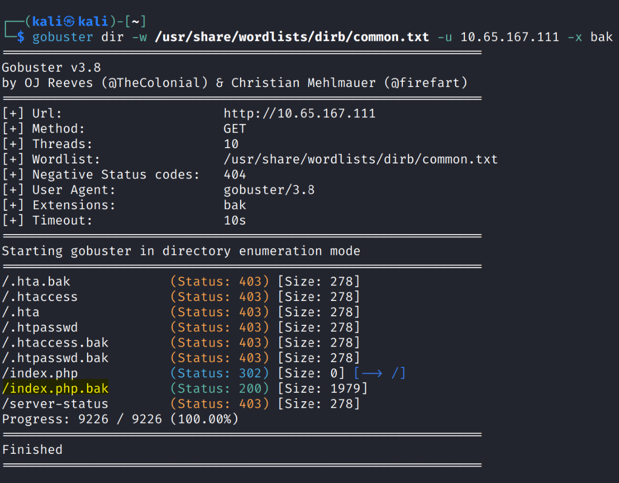
I found here a file named “index.php.bak” and I opened it on the website. This action made the file to be downloaded to my machine, and this is how it looks like:
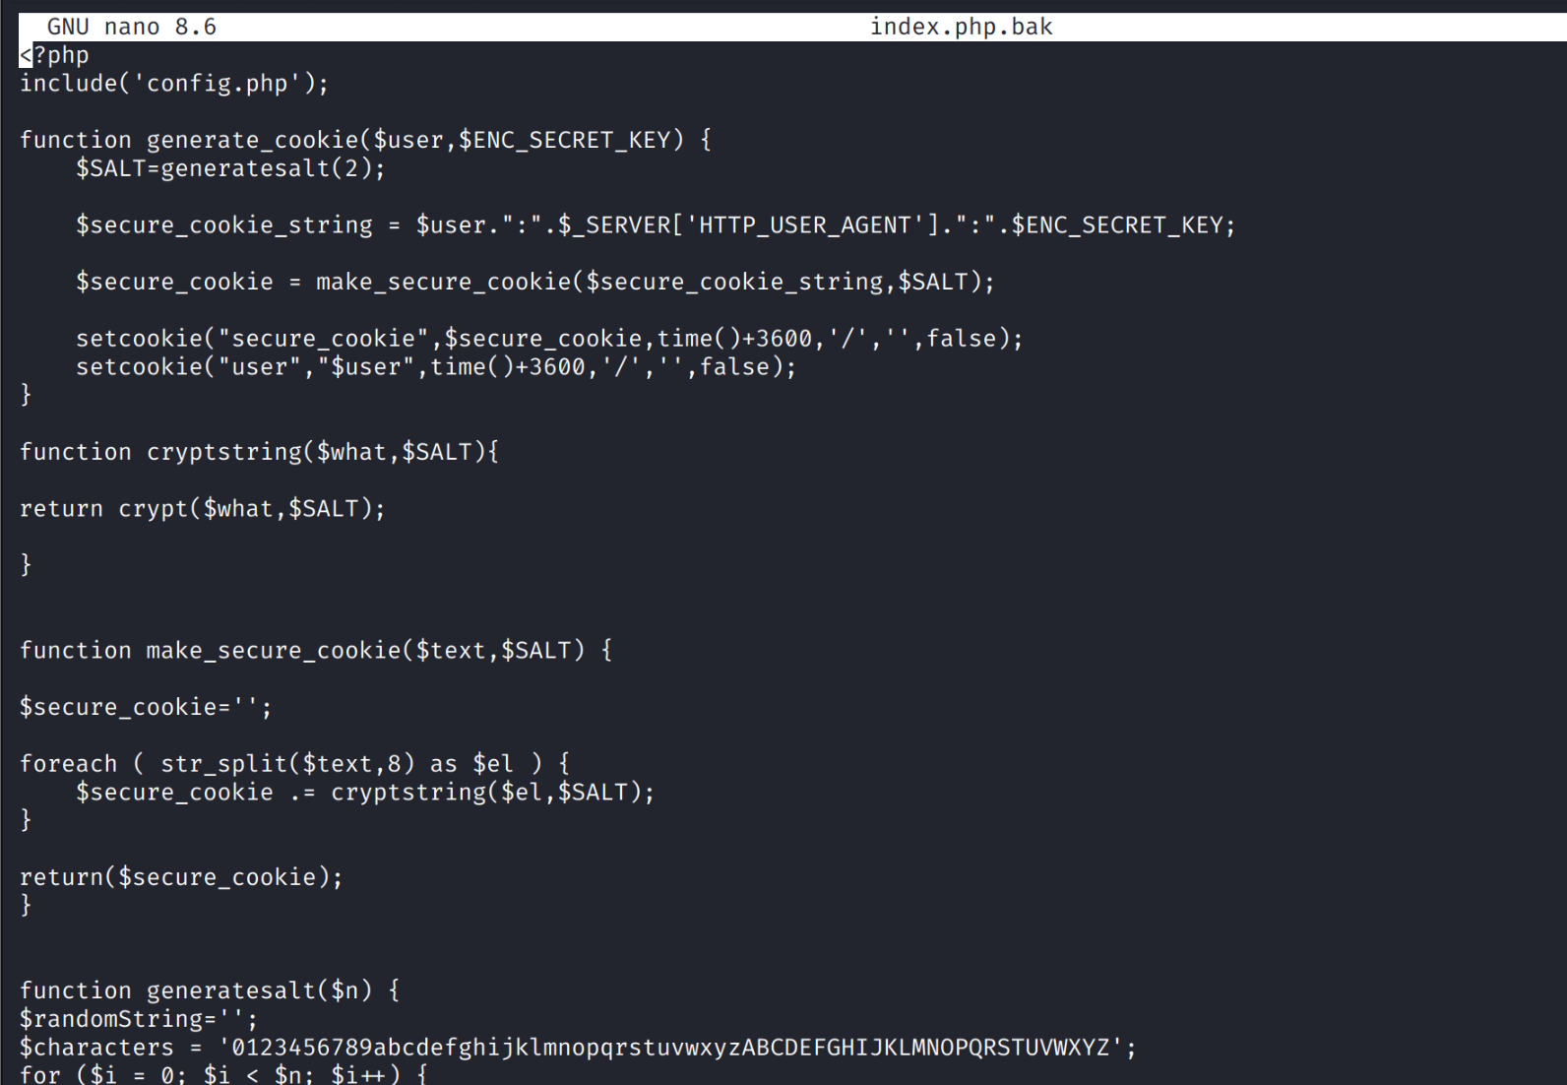
I read the file and understood that this is the source code of the index.php file and the entire mechanism of the cookies management.
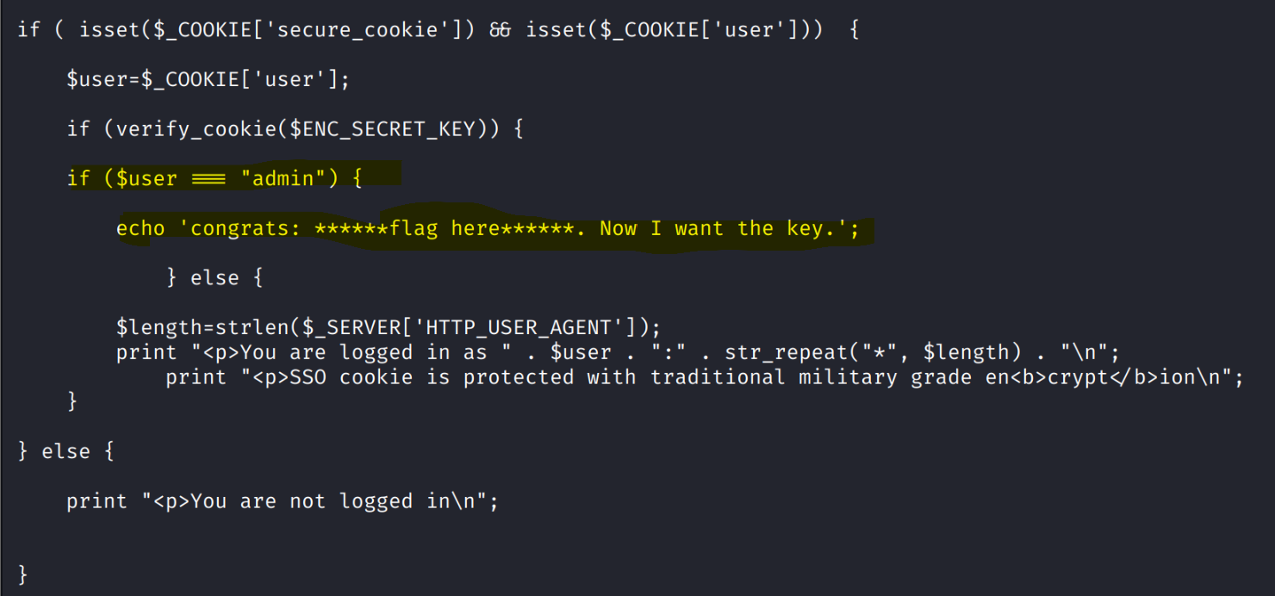
I paid attention to this specific “if” statement that checks if the user is admin it will echo the website flag. This if statement can be run only after the secure_cookie value was verified by a function named “verify_cookie()”.
After analyzing all the functions in the script, I understood that the secure_cookie is a string that consists of several hashes that were joined together and each one of them was created by hashing a split of a 8 characters (with a salt string with 2 characters length using the function “crypt”) of a specific string which contains this information in this format: “user:http-user-agent:enc-secret-key”.
I also understood that I can change the first hash in the secure_cookie to another hash that was created by a hash of a substring that contained the word “admin” instead of “guest” in the user parameter by knowing the salt value. The salt value can be discovered by simple bruteforce using this python script that I wrote for this specific task:
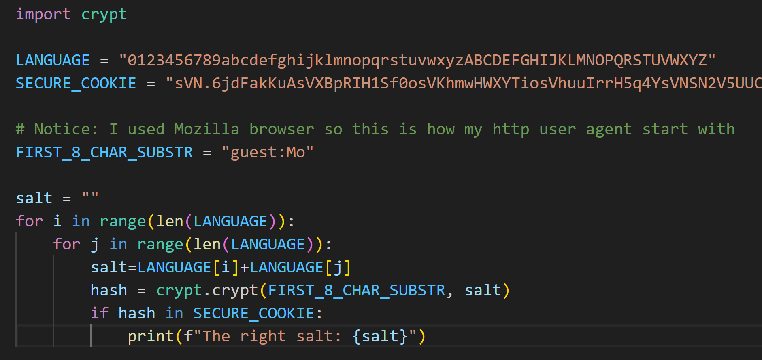
After executing it I found that the right salt that was randomly chose for me was “sV”:
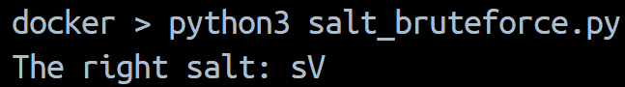
- Notice: I used docker here only because the crypto fucntion was totally removed from python 3.13 so it was the fastest way for me to run this script of a lower version (I used here 3.6).
Now, I created this substring “admin:Mo” to

